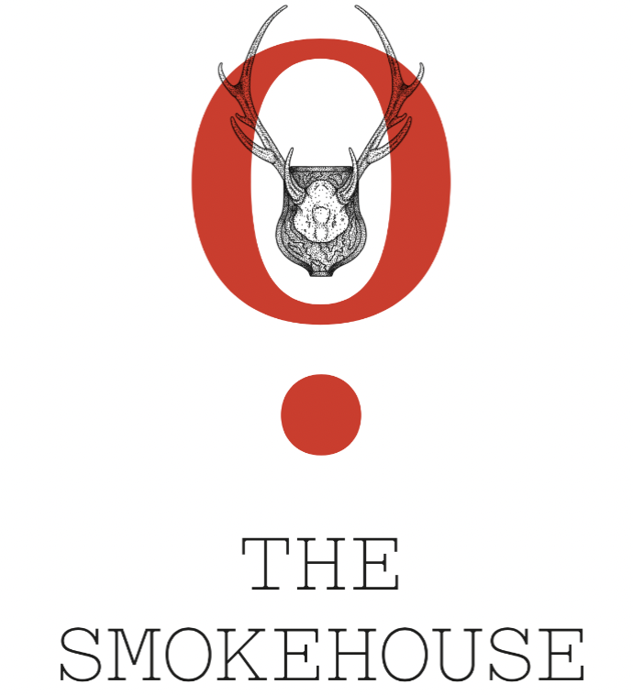

SAMPLE MENU
Bramble 13 / House Bloody Mary 12/ Islington Old Fashioned 12

Smoked House Nuts 4 / Sicilian Olives 5
Sourdough, Beef Dripping, Butter 7 / Mixed Anchovy Fillets, Herb Oil 8
Pistachio Mortadella, Pickled Chilli 8 / Wood Roasted Padron Peppers 7

Grilled Goats Cheese, Chestnut Honey, Walnuts (V) 8
Wiltshire Beetroots, Pickled Fennel, Goats Curd, Olive Crumb (V) 9
Roast Butternut Squash Soup, Fried Sage, Toasted Crostini (V) 9
Burnt Leek, Black Truffle Dressing, Parmesan 9
Burrata, Courgette Pesto, Hazelnuts (V) 12

OUR ROASTS
Vegetable Wellington, Celeriac, Spinach, Button Mushrooms (V/VE) 20
50 Day Dry Aged Dexter Beef Sirloin (served pink) 26
Smoked Tamworth Porchetta 23
Braised Hereford Lamb Shoulder (for 2 to share) 54
Roasted Free Range Chicken Crown (for 2 to share) 52

Our roasts are served with roast potatoes, seasonal greens, honey glazed carrots & Yorkshire pudding.

Pan Fried Hake, Butter Sauce, Capers, Samphire, New Potato 28

Extra Yorkshire 2 / Greens 5 /Cauliflower Cheese 6 /Roast Potatoes 6 /Honey glazed Carrots 5

