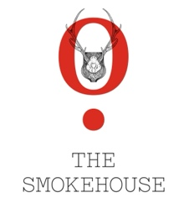

Feasting Menu

£55

All dishes are served ‘family style’ on vintage sharing platters for the whole table to enjoy

Short Rib Croquette, Garlic Aioli

Mozzarella and Beetroot Salad (v) (gf)

Citrus Cured Salmon, Buttermilk Dressing, Braised Fennel. (gf)

Ham Hock Terrine, Cornichons, Crostini

Please choose 2 of the main courses for the table

45 Day Aged Beef Rump, Roast Shallots (gf)

Whole Free-Range Chicken, Chicken Sausage, Tarragon Sauce (gf)

Whole Slow Cooked Lamb Shoulder, Mint Chimichurri (gf)

Whole Market Fish, Brown Crab Bisque (gf)

Salt Bake Celeriac, Kale, Chilli (vg) (gf)

All served with a selection of Seasonal Sides and roast potatoes

Vanilla Cheesecake, Blood Orange (v)

Sticky Toffee Pudding, Vanilla Ice Cream (v)

There will be enough food for everybody in the party to enjoy
We can absolutely cater for all allergies and dietary requirements

